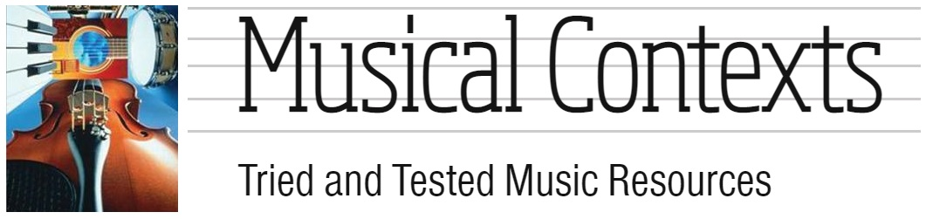

Musical Contexts Invoice Order Form

Many thanks for requesting an invoice for resources from Musical Contexts.
Any items from the “Shop and Add-On Extras” page, including ’99 Zone Access’, can now be paid via BACS/CHAPS.
Please complete the details below and email this form back to payments@musicalcontexts.co.uk, whereupon I will generate an invoice based on the details given.
If you would like to include an official Purchase Order, then please insert the number in the details below and attach it when returning this form via email.
Name of School, College or Academy:
School, College or Academy Address:
Name of the Music Teacher/Lead:
Music Teacher/Lead email:
Name of person for Accounts Payable (Bursar/Business Manager):
Bursar/Business Manager email:
Purchase Order (or reference number):

Quantity | Resource Description | Price (£)
GRAND TOTAL (£)

Please note that resources cannot be provided until payment has been received.
The registered address for Musical Contexts is: Musical Contexts, 11 Prospect Court, Sydenham Road, Guildford, Surrey, GU1 3ST.
Invoices can be paid by: BACS/CHAPS: Bank Details for BACS/CHAPS payments: Bank – Halifax; Account Name – MR R O BLYTHE, Sort Code – 110033; Account Number – 13138361. BACS details can be confirmed by calling 07931 734145. Musical Contexts is not registered for VAT, nor with “Companies House” and operates as a self-employed sole trader with the HMRC with a UTR of 641195699.

